Geography 415

Getting started with R Studio

1. Decide on which method you will use for R studio: your own computer, apps@UT, or the department computer.
2. Decide where you will put your class folder with documents. If using R Studio on your own computer, you can make a class folder anywhere you like. But if you are using Apps@UT or the department computers, they you will want to use T Storage. You can find out about T Storage here: <https://help.utk.edu/kb/index.php?func=show&e=1602>

The process for making T Storage available on your own computer is called “mapping a T-Storage Drive”. The link has instructions for doing this on a Windows or Mac.

Overview of R studio: 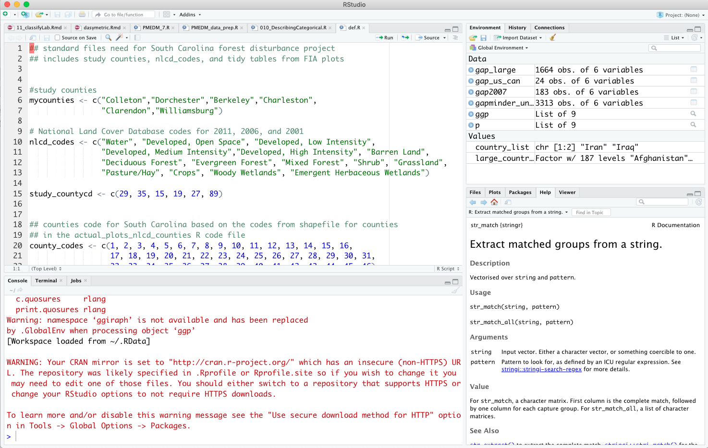

File Browser

Help Manual

Plots

Environment

R Console

DOCUMENTS

When you open up R Studio, you will see it layed out with 4 window panes.

* The top left is where you see all your open documents.
* The bottom left is R. It’s where stuff actually happens.
* The top right is your “Environment”. It shows a list of all the data and variables that your have created.
* The bottom right has everything else: a file browser of your computer, the help manual, and any plots that you have created.

Good to never forget:

- **R commands will only be saved if they are in a document.**

- R commands will only be run if they are in the console.

There are lots of shortcuts for sending commands from a document to the console. Mostly importantly:

* Click the run button to run a line
* Type Command + Enter to run the current line
* Click the source button to run all lines
* Click the knit button to run all lines of a markdown document

Everyone uses R Studio differently, but what works for me:

* Everything happens in a document.
* **Everything happens in a document.**
* When I type a new line, I send it to the console using one of the methods above.
* If I get an error, I fix it and try again.
* If there is no error, then I go to the environment (top right) and see that the data looks like I expect. If not, I fix the document and try again.
* Go on the next thing and repeat.
* Periodically, source or knit the entire document to make sure everything works from beginning to end. (There’s a clickable button to “source on save”… that’s good to use)

**Creating Your first R markdown Document**

Click File -> New File -> R Markdown…

You will see the following Window

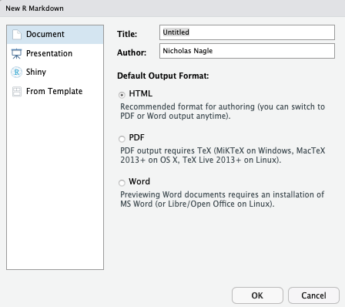

Change the title to something like “My first markdown document” and make yourself the author. Click OK.

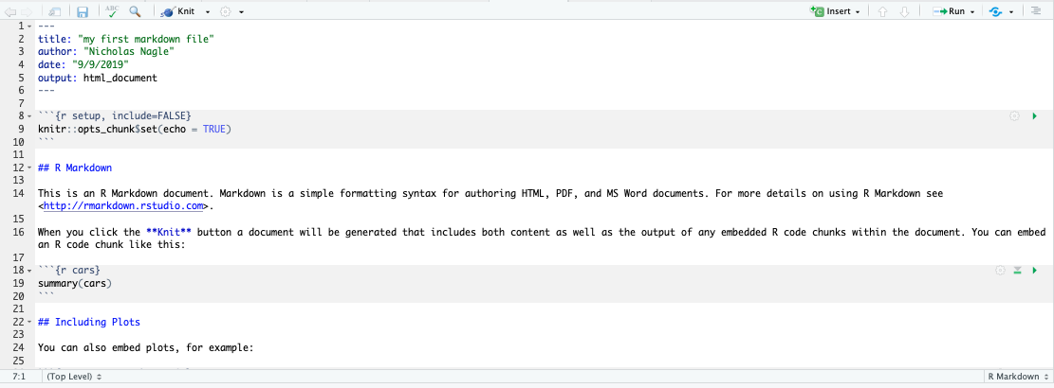

The file will look something like this. There are three section to an R markdown file.

1. The header. It starts like:

---

title:

author:

other stuff

---

Other than changing the title and author, don’t mess with the header. You might break your file.

1. There are also R code chunks. They l

```{r}

Code

More code

```

Anything that is printed out by an r code chunk (numbers or plots) will be inserted into your document.

1. Other text. Write just as you normally would outside the header and R code chunks.

Take a look at the markdown document.

Then click the knit button.

It will create a new html document.

**Take a moment to compare the .Rmd file and the html document.**

Can you see how everything in the .Rmd file shows up in the html document? Look at how sections, web links, emphasized text and pots are created.

If you don’t understand, go ahead and ask the TA.

You can now open up the tutorial .Rmd file and look through that.